Task 1: Common Network Threats and Real-World Examples

Threat | What It Is | Real-World Example | Mitigation
Phishing | Social engineering attacks that use deceptive emails, messages, or websites to manipulate users into exposing confidential data such as passwords, OTPs, or financial details. | Paytm / Banking: Fraudulent SMS claiming "Your Paytm KYC has expired! Click paytm-verify-kyc.net to unlock your wallet," which steals entered account credentials and UPI PINs. | Deploy DMARC/SPF email filtering, use anti-phishing browser security, and enforce hardware security keys or app-based MFA instead of SMS OTPs.
DDoS (Distributed Denial of Service) | Flooding network resources, reverse proxies, or DNS resolvers with traffic from a distributed botnet to exhaust bandwidth or server compute, denying service so real users can’t get through. | BookMyShow / Zomato: Attackers flood a ticket-booking or food-ordering service during a high-demand sale so it times out for genuine users. | Implement upstream traffic scrubbing centers, deploy Anycast DNS/CDNs (e.g., Cloudflare), and configure rate-limiting alongside Web Application Firewalls (WAF).
Man-in-the-Middle (MitM) | An attacker secretly intercepts, relays, or alters communication between two parties systems without their knowledge, typically via ARP spoofing, rogue access points, or DNS poisoning. | WhatsApp / Public WIFI: Connecting to an open café/Railway Station Wi-Fi network where an attacker runs ARP cache poisoning to intercept unencrypted outbound network traffic and inspect packet streams like Instagram login or session. | Use HTTPS/VPN, avoid public Wi-Fi for logins, check certificate warnings.
Malware (Trojan / Keylogger) | Malicious software that steals data, spies or damages devices. | WhatsApp: A fake “WhatsApp Pink” or modified APK shared via a link installs spyware that reads messages and OTPs. | Install only from Play Store, keep Play Protect and antivirus on, never sideload APKs.
Password Attacks (Brute-Force / Credential Stuffing) | Automated programs repeatedly submitting dictionary lists, numeric sequences, or previously breached password dumps to compromise user accounts. | Flipkart: Threat actors running automated bot scripts using compromised credentials from third-party data breaches to break into customer accounts with saved credit cards. | Unique strong passwords, 2FA, account lockout, password manager

Task 2: 4-Digit PIN Brute-Force Attack Simulation using Python

import time
def simulate_pin_bruteforce(target_pin: str):
"""
Simulates an automated linear brute-force dictionary/counter attack
against a 4-digit numeric PIN code.
"""
if len(target_pin) != 4 or not target_pin.isdigit():
raise ValueError("Target PIN must be a 4-digit string between '0000' and '9999'.")
print(f"[+] Initializing brute-force attack on target PIN...")
start_time = time.perf_counter()
attempts = 0
cracked = False
discovered_pin = None
# Iterate through all 4-digit permutations (0000 through 9999)
for candidate in range(10000):
attempts += 1
guess = f"{candidate:04d}" # Pads integers with leading zeros
if guess == target_pin:
cracked = True
discovered_pin = guess
break
elapsed_time = time.perf_counter() - start_time
if cracked:
print("\n" + "=" * 45)
print(" CRACK SUCCESSFUL!")
print("=" * 45)
print(f" Target PIN : {discovered_pin}")
print(f" Total Attempts Taken: {attempts:,}")
print(f" Elapsed Time : {elapsed_time:.4f} seconds")
print("=" * 45)
else:
print("[-] Exhausted search space without discovering PIN.")
if __name__ == "__main__":
# Preset test PIN (e.g., simulating a user's wallet PIN)
SECRET_PIN = "7492"
simulate_pin_bruteforce(SECRET_PIN)
Output
[+] Initializing brute-force attack on target PIN...
=============================================
CRACK SUCCESSFUL!
=============================================
Target PIN : 7492
Total Attempts Taken : 7,493
Elapsed Time : 0.0019 seconds
=============================================
- The PIN falls instantly because there are only 10,000 combinations and nothing slows the guesses. Mitigations are account lockout after 3 to 5 wrong tries, increasing delays between attempts, longer PINs or passwords, and 2FA.

Task 3: Physical Security Risks for App Server Rooms

Physical Security Risk | Operational Consequence | Recommended Mitigation Step
Tailgating / Unauthorized Facility Access | An unauthorized individual follows an authorized technician through an unlatched door, gaining physical access to pull drives, insert infected USB drives, or tap network cables. | Biometric Mantrap / Air-lock Door Systems: Deploy a two-door interlock vestibule where Door 2 opens only after Door 1 closes and the visitor validates dual-factor biometrics (e.g., iris scan or fingerprint + RFID keycard).
HVAC & Environmental Thermal Runaway | Server room air conditioning units fail, causing rack temperatures to spike past thermal thresholds, resulting in emergency hardware CPU throttling or thermal shutdown of database clusters. | Redundant N+1 Precision HVAC with Automated Environmental Sensors: Deploy dual-system climate control backed by real-time IoT temperature/humidity sensors that trigger automated administrator SMS alerts and load shifts if temperatures exceed 24°C.
Water Leakage & Flooding | Burst municipal water pipes, building plumbing leaks, or ceiling AC condensation drip onto server chassis and power distribution units (PDUs), causing short circuits and component damage. | Raised Flooring & Conductive Rope Water Sensors: Position server racks on 30–60 cm raised plenum floors, route all facility water pipes outside server boundaries, and install fluid-detection rope sensors connected to central telemetry.
Uninterrupted Power Failure & Voltage Surges | Grid utility blackout or voltage spikes crash storage area networks (SANs) and edge switches mid-transaction, leading to database index corruption and service blackouts. | Online Double-Conversion Industrial UPS & Standby Diesel Generators: Install continuous double-conversion battery UPS systems backed by automated transfer switches (ATS) tied to dual diesel generators capable of holding full server load within 10 seconds of grid failure.

Task 4: Small Office Floor Plan with Physical Security Controls

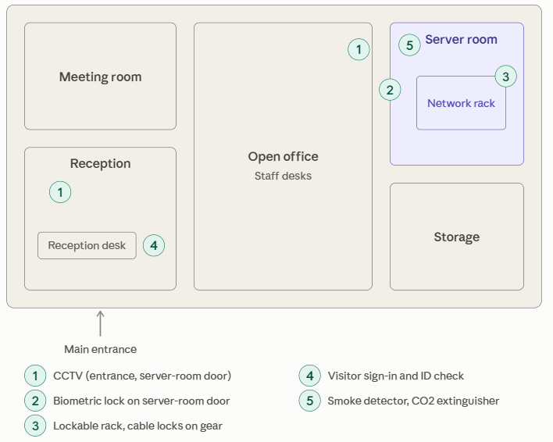

TASK 5: Checklist To Mitigate Network Threats And Physical
Security Breaches for a College Computer Lab

Reviewed and edited for a college computer lab:
- Segment the network: put student lab PCs on their own VLAN, separate from faculty and admin systems, with firewall rules that allow only needed ports (web, DNS) and block outbound SMTP (25) and file-sharing traffic.
- Give every student an individual login (e.g. a Windows Active Directory account) with standard-user rights only. Remove shared “student” accounts, enforce a password policy, and require MFA for faculty and admin accounts.
- Keep lab PCs identical and protected: use a restore-on-reboot or disk-imaging tool so changes are wiped, schedule patches and antivirus updates outside lab hours, and disable or scan USB ports.
- Harden the network devices: change default passwords on switches and access points, shut down unused switch ports, enable port security, and ban personal routers or hotspots plugged into the lab network (rogue access points).
- Secure the equipment physically: keep switches and routers in a locked cabinet with the key held by the lab in-charge, fit cable locks on PCs, put CCTV over the entrance and rows of machines, and keep a visitor and student entry log or ID swipe.
- Log and review: collect logs centrally (syslog and content-filter or proxy logs), review them weekly for unusual activity such as port scans or blocked sites, and set auto-logout after idle time.
- Prepare for failures: back up switch and router configurations and the project server nightly, use UPS and surge protection for lab equipment, check smoke detectors and CO2 extinguishers monthly, and run a short phishing and acceptable-use briefing at the start of each semester.
What I changed from the draft: items 1 to 4 and 6 now name lab-specific controls (student VLAN, individual logins, restore-on-reboot, port security), and items 5 and 7 add the physical measures a lab actually needs (cabinet keys, cable locks, CCTV, UPS, fire protection)

